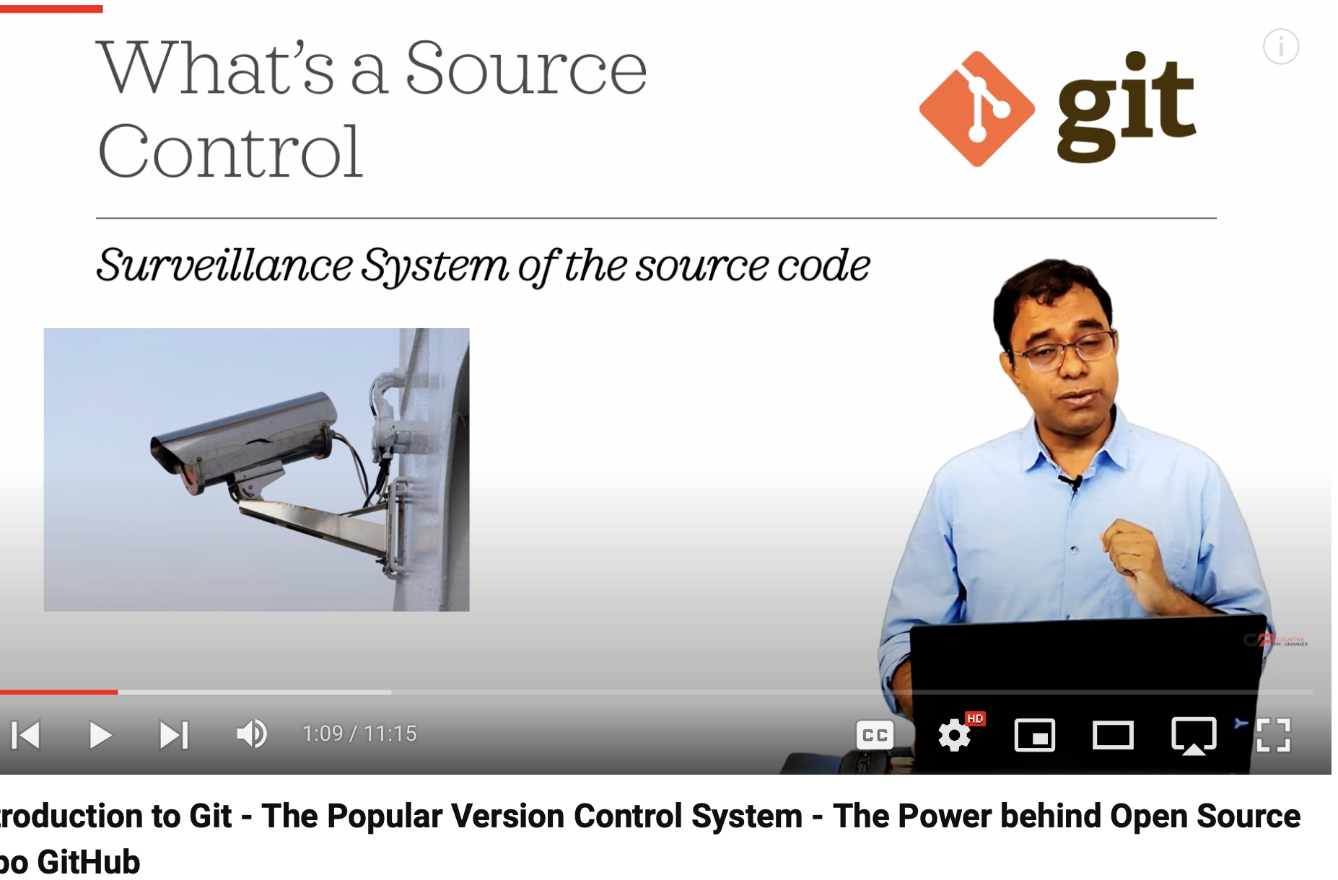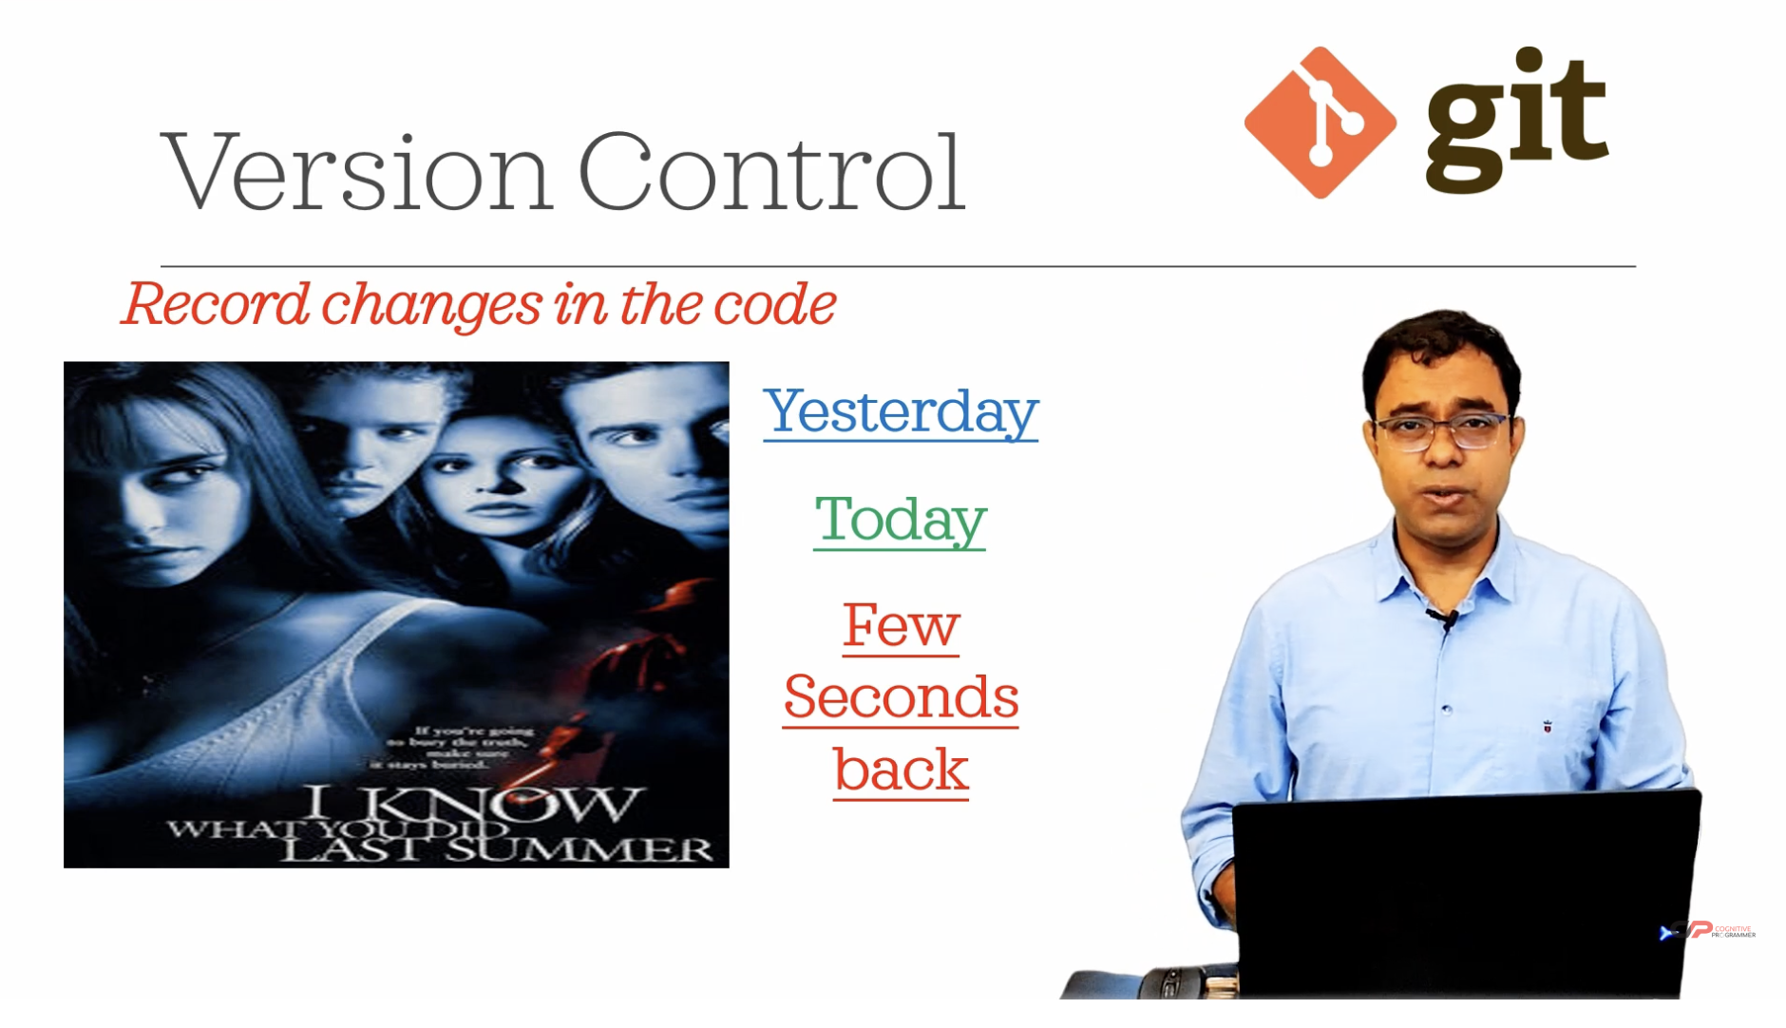

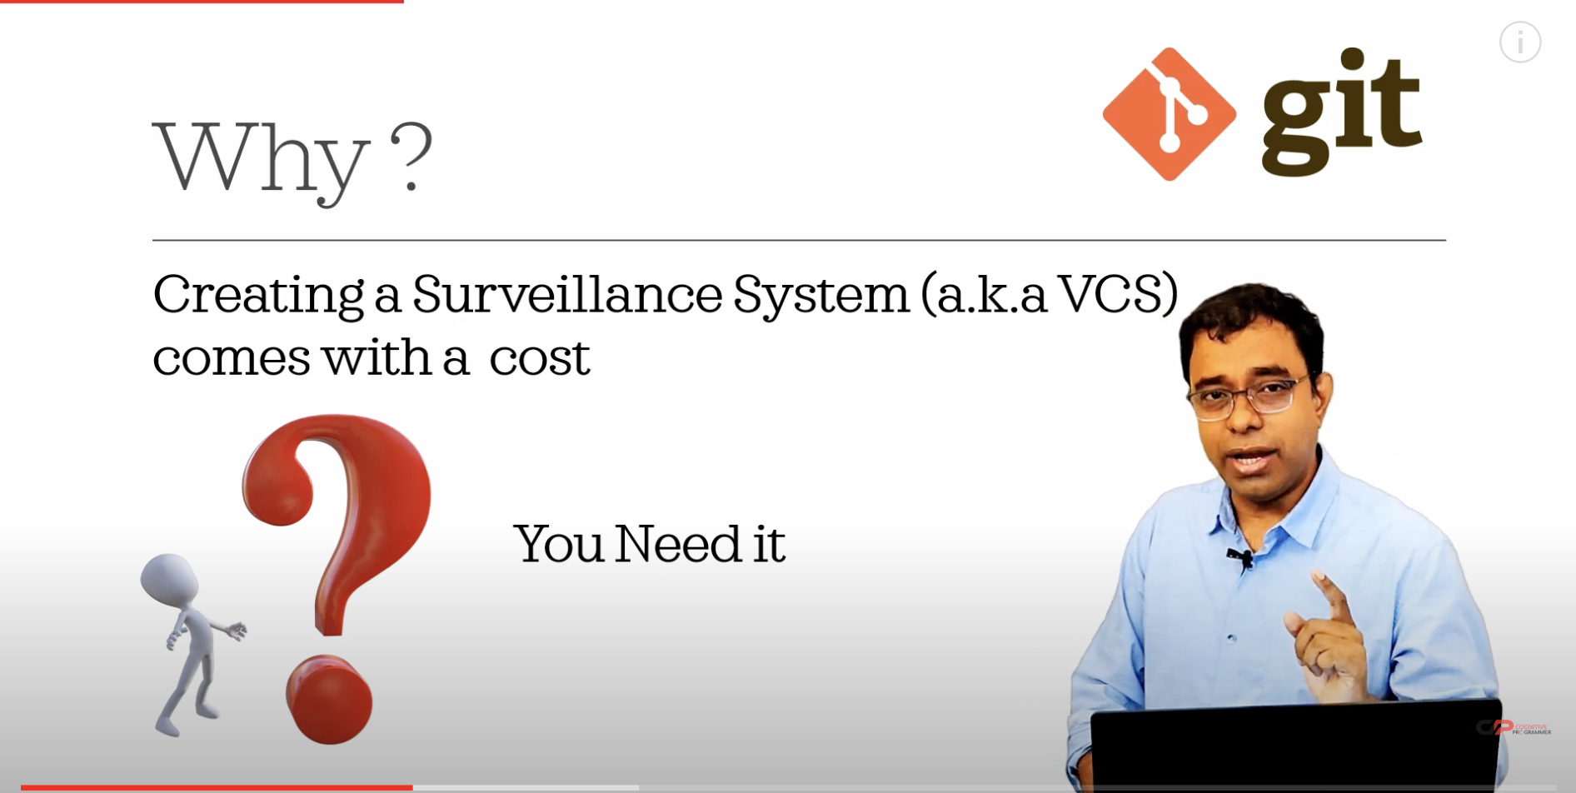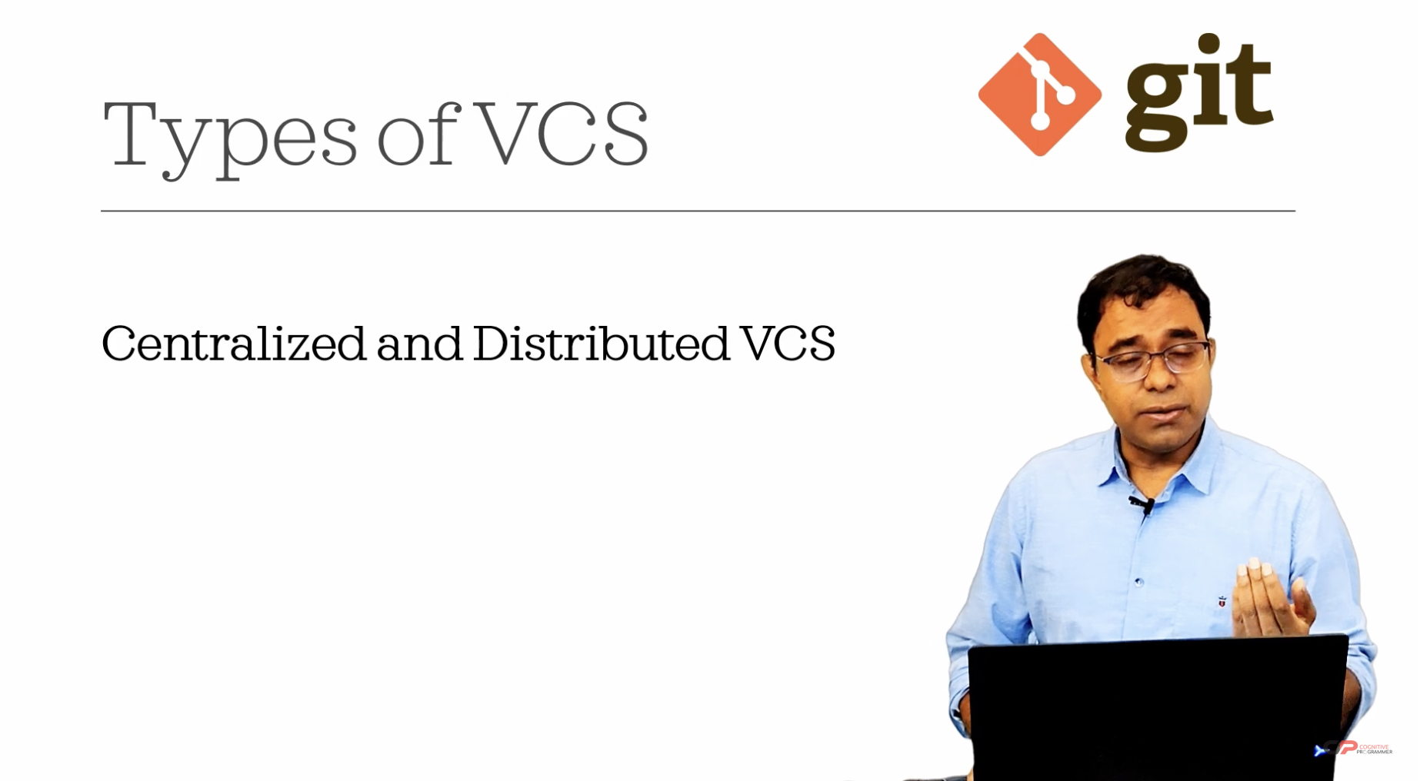

SVN is a centralized and git is a decentralized version control system.

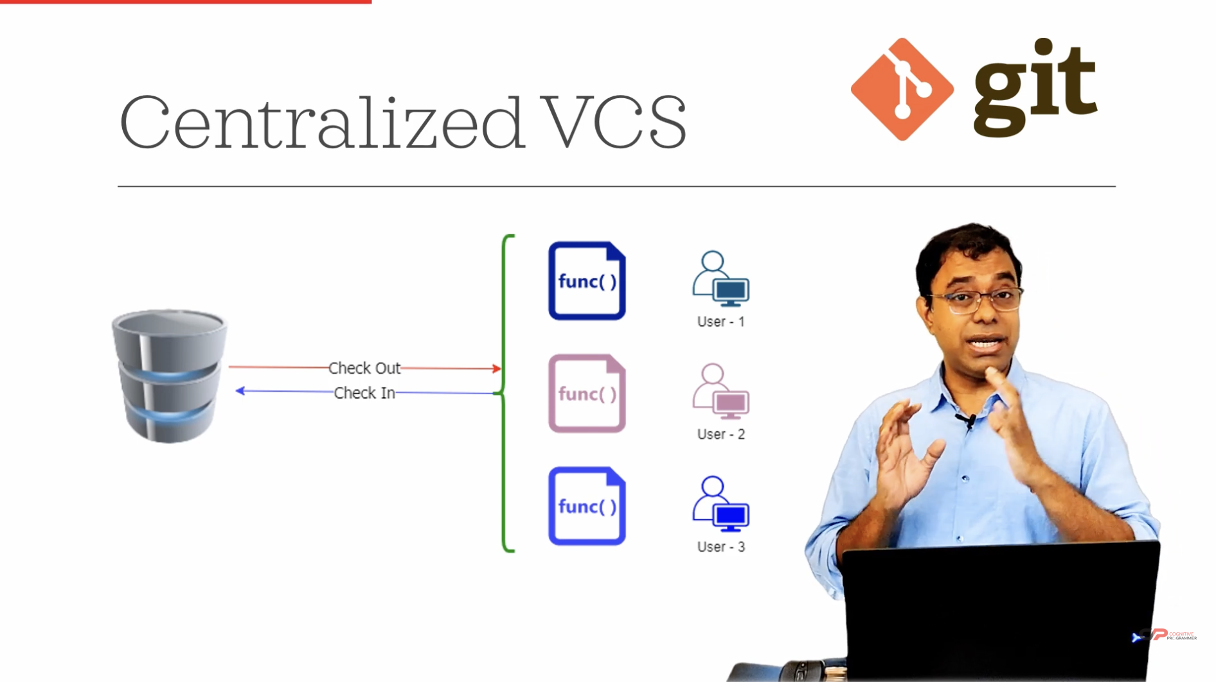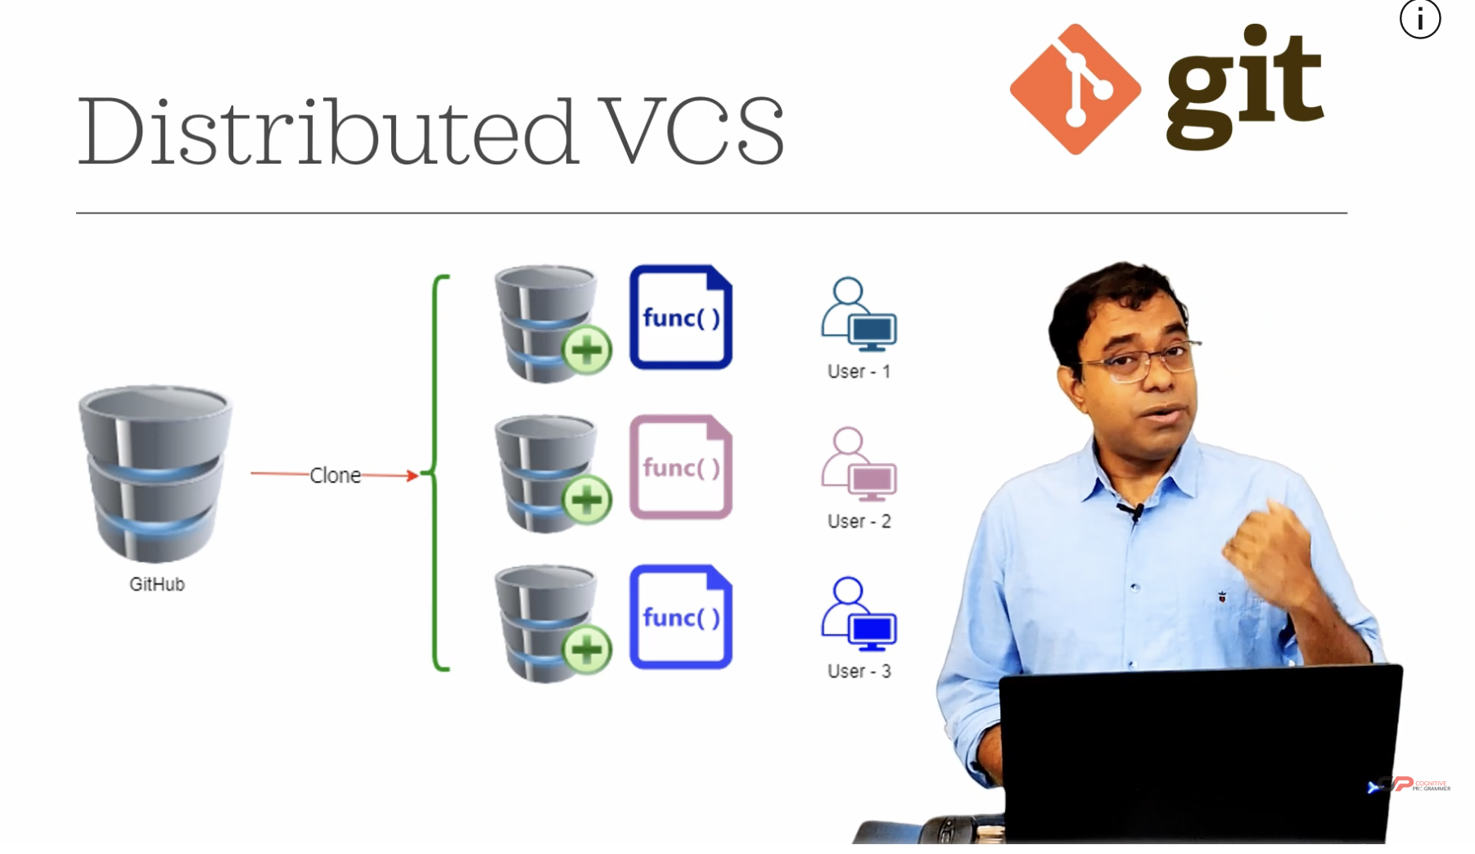

Your explanation captures the fundamental differences between Centralized Version Control Systems (CVCS) like SVN and Distributed Version Control Systems (DVCS) like Git. Here’s a brief overview to further clarify:

**Centralized Version Control Systems (CVCS)**

* **Server-Centric**: In CVCS, all version control activities are managed through a central server. The server holds the complete history and current state of the project.
* **Check Out/In**: Users check out files from the server to work on them and must check them back in to update the server. This often means that only one person can work on a file at a time.
* **Network Dependency**: Working with the version history requires a constant connection to the central server, as all the versioning information is stored there.

**Example**: Subversion (SVN)

**Distributed Version Control Systems (DVCS)**

* **Local Repositories**: In DVCS, every user has a full copy of the repository, including the entire history, on their local machine. This allows users to work offline.
* **Local Operations**: Users can commit changes, view history, and branch without needing a network connection because all operations are performed locally.
* **Synchronization**: Changes can be synchronized with other repositories (e.g., on GitHub) when a connection is available. This is typically done by pushing changes to or pulling changes from the remote repository.

**Example**: Git

**Key Differences**

* **Flexibility**: DVCS allows multiple people to work on the same files simultaneously without interfering with each other.
* **Offline Capabilities**: DVCS supports offline work because users have complete local repositories.
* **Collaboration**: DVCS enables easier collaboration through branching and merging, allowing multiple workflows and features to be developed simultaneously.

This model allows for a more decentralized workflow, where individual contributors can work independently and then merge changes into a shared central repository, facilitating collaboration and flexibility.

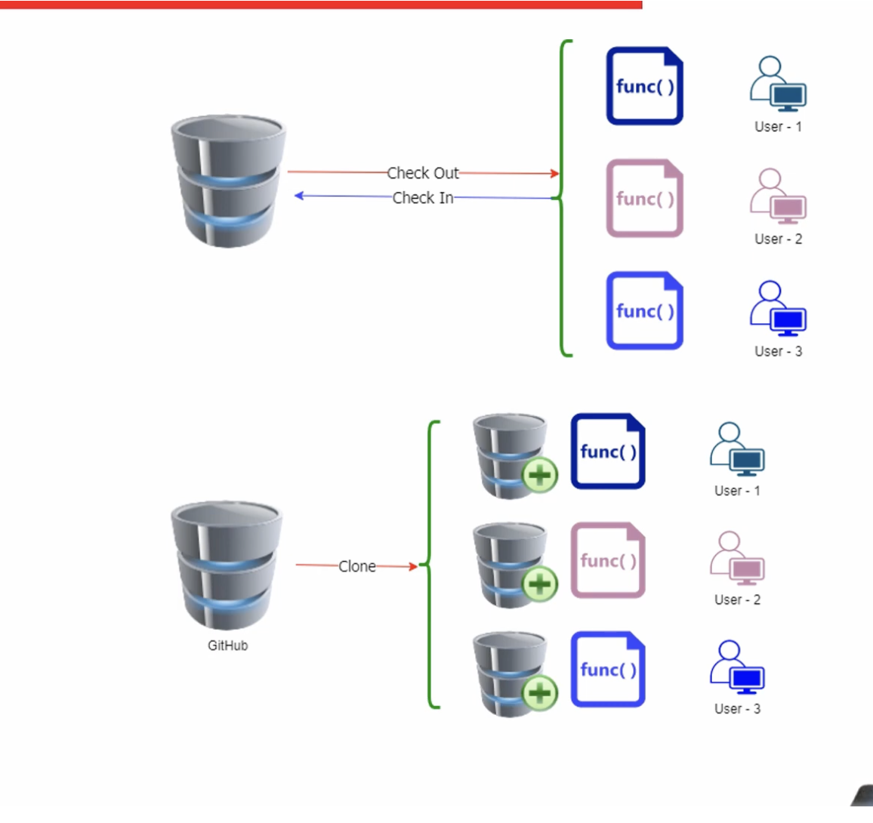So let's see side-by-side. The top one is centralized version control system. The bottom one is distributed version control system. You understand the difference. In centralized version control system, nothing comes in the user system and user cannot work on the file. Work means that you cannot check back your changes unless you are connected to the centralized version control system, which is not required in Git. Now we understood that Git is a distributed version control system.

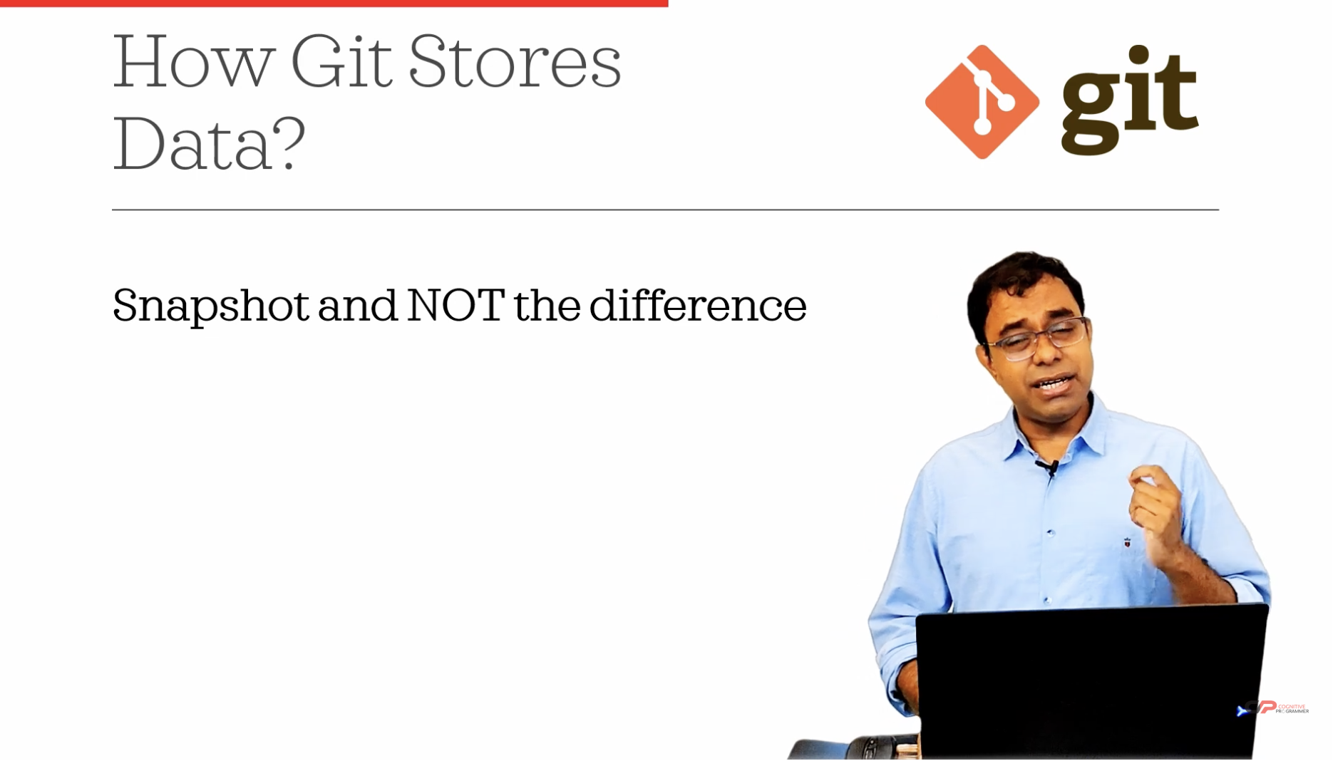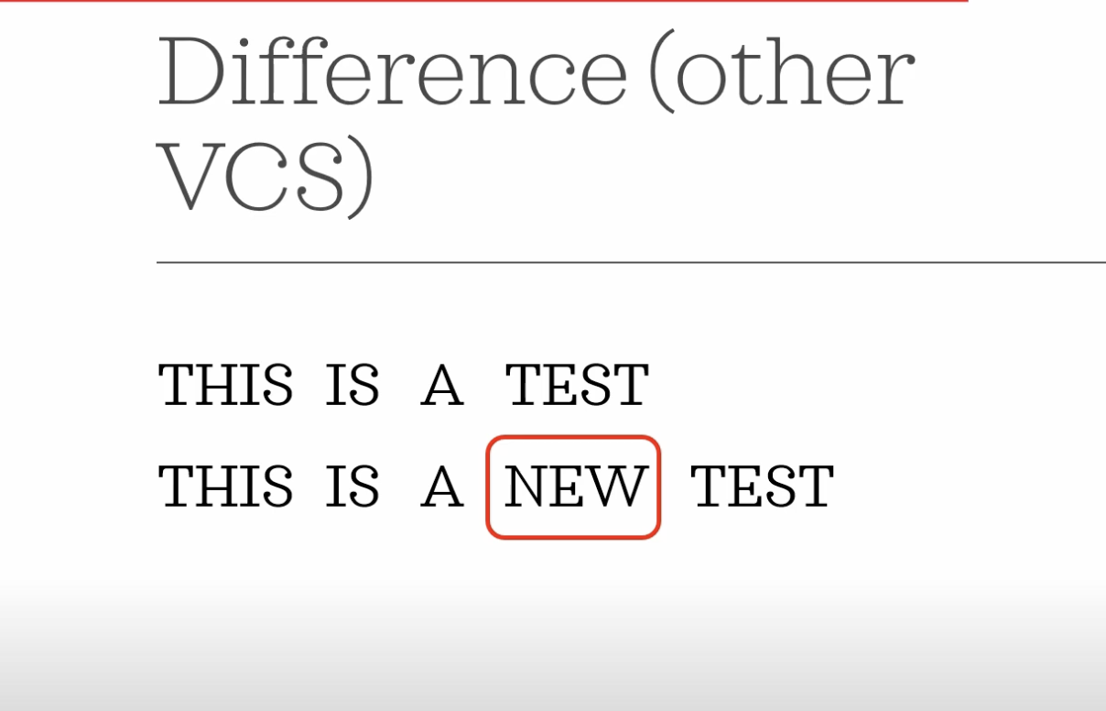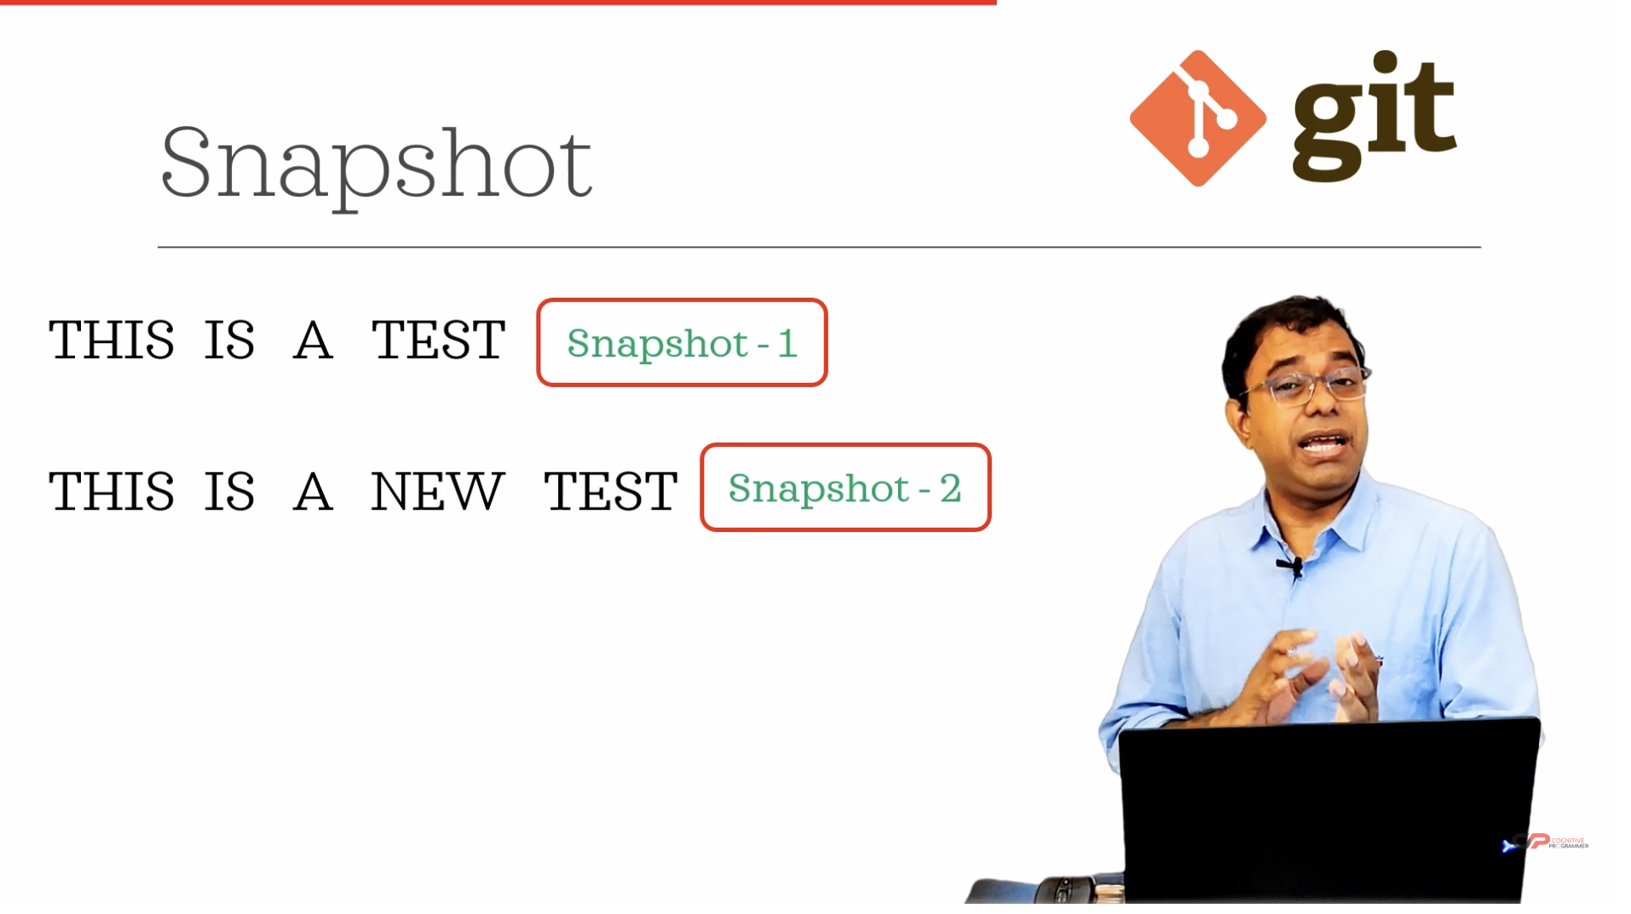

Your explanation highlights a fundamental aspect of how Git manages and stores data compared to other version control systems. Here's a breakdown of the key differences in data storage between Git and other version control systems:

**Traditional Version Control Systems**

* **Delta Storage**: Many traditional version control systems, like SVN, store the differences (or "deltas") between file versions. This means that they record changes made to files by comparing the new version to the previous one and storing only the changes.

**Example**:

* + **Original File**: "This is a test."
  + **Updated File**: "This is a new test."
  + **Stored Delta**: "new" (indicating the addition of the word "new").
* **Efficiency**: This approach can be efficient in terms of storage because only the changes (or deltas) are stored rather than the entire file, which can save space when changes are small.

**Git's Snapshot Storage**

* **Snapshot Storage**: Git takes a different approach by storing snapshots of the entire file system. Every time you commit changes, Git saves the state of your project as a complete snapshot.

**Example**:

* + **First Snapshot**: "This is a test."
  + **Second Snapshot**: "This is a new test."

Each commit in Git is a full snapshot of the file at that time.

* **Efficiency with Compression**: Despite storing complete snapshots, Git uses techniques like compression and deduplication to efficiently manage disk space. Identical files or file parts are stored only once.
* **Advantages**:
  + **Integrity**: Storing full snapshots ensures that the project can be accurately recreated at any commit point without relying on reconstructing files from a series of changes.
  + **Speed**: Operations like branching and merging are faster because Git deals with entire snapshots rather than piecing together changes.

**Summary**

The key distinction is that while traditional systems focus on storing the changes between file versions, Git captures the entire state of the project at each commit. This snapshot-based approach simplifies many version control tasks and enhances reliability and performance, particularly when working with complex histories or branching scenarios. This fundamental difference is why Git is often preferred for distributed development and large projects.

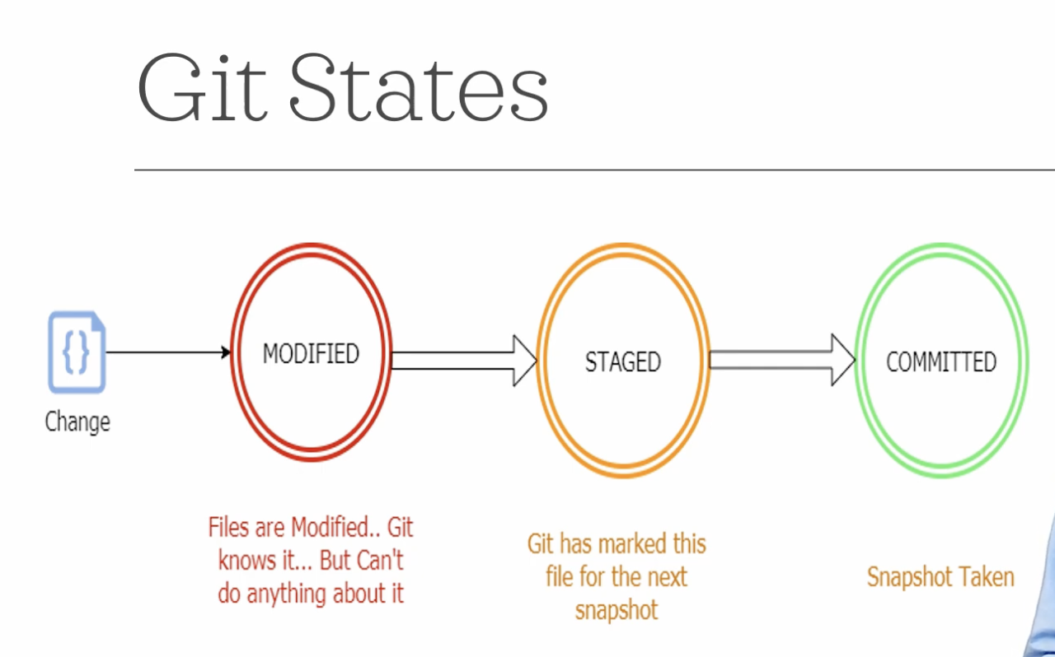

Your explanation of Git states is clear and captures the essential steps in tracking and managing changes within a Git repository. Here’s a breakdown of the three key states in Git:

**Git States**

1. **Modified**
   * **Description**: When you make changes to a file in your working directory (your local copy of the repository), Git recognizes that these files have been altered. At this point, the changes are in a "Modified" state.
   * **Significance**: Git is aware of the changes but hasn’t done anything with them yet. The modified state is essentially a local change that has not been staged or committed.
2. **Staged**
   * **Description**: To prepare your changes for a commit, you add them to the staging area using the git add command. This moves the changes from "Modified" to "Staged."
   * **Significance**: The staging area is a preparation zone where you can gather all the changes you want to include in your next commit. Staging allows you to selectively choose which modifications will be part of the commit, giving you control over what gets recorded in the repository’s history.
3. **Committed**
   * **Description**: Once your changes are staged, you can commit them to the repository with the git commitcommand. This creates a new snapshot of your current changes.
   * **Significance**: The "Committed" state represents a point in the repository’s history. This is a permanent snapshot of the changes, stored in the repository’s history, and can be reverted to or referenced in the future.

**Summary of Git Workflow**

* **Modify**: Make changes to files in your working directory.
* **Stage**: Add the changes you want to include in the next commit to the staging area using git add.
* **Commit**: Record the changes in the repository’s history with git commit, creating a snapshot of your project at that point in time.

Understanding these states is crucial for effectively using Git, as they provide a structured approach to managing changes, allowing you to control what gets saved in your project’s history and when. This workflow enables you to work on multiple features or fixes simultaneously without affecting the main project code until you are ready to commit them.

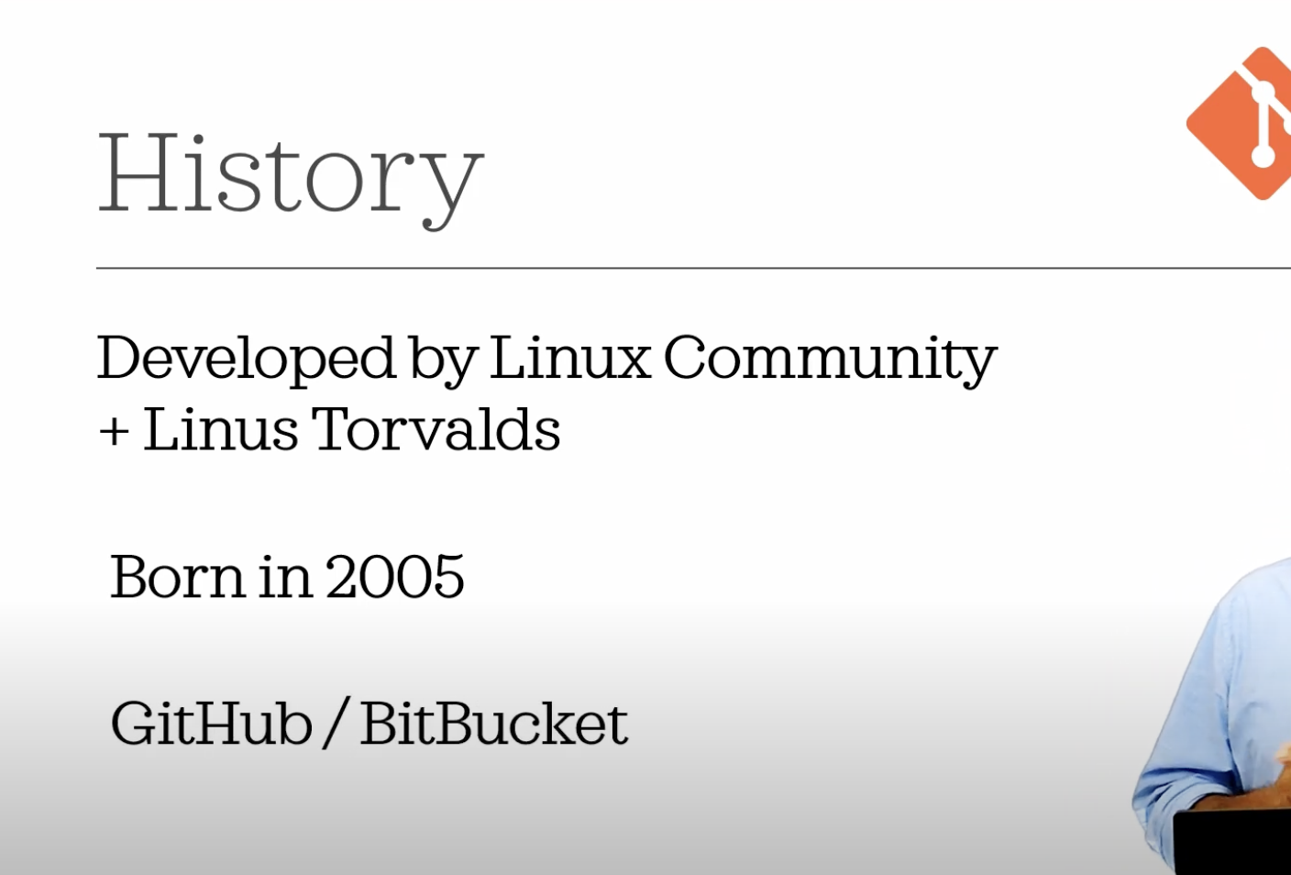

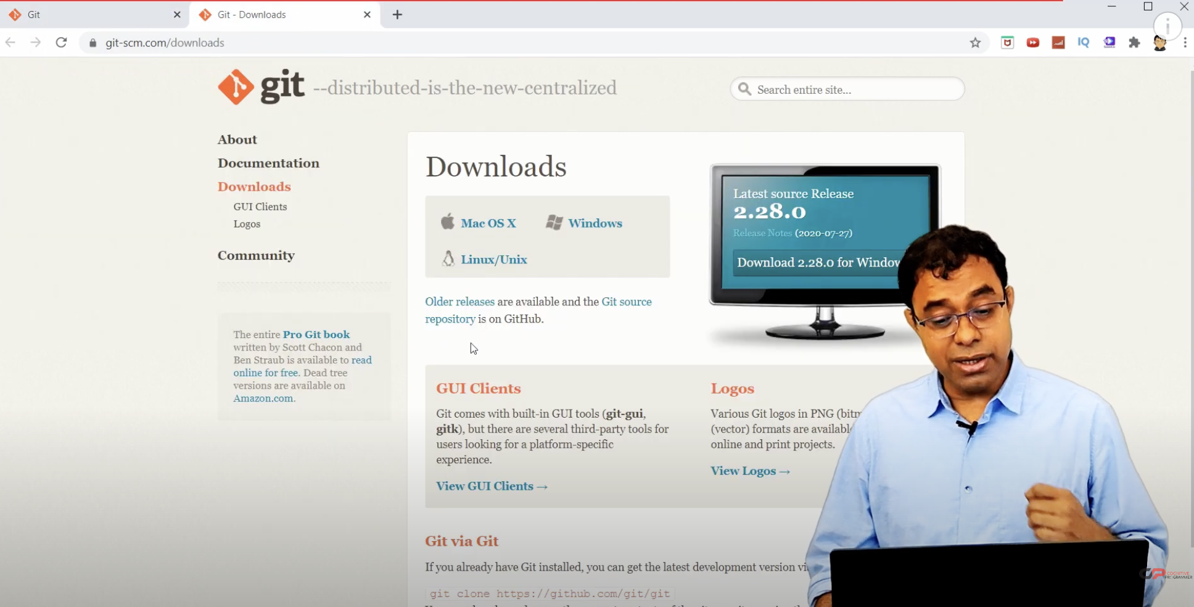

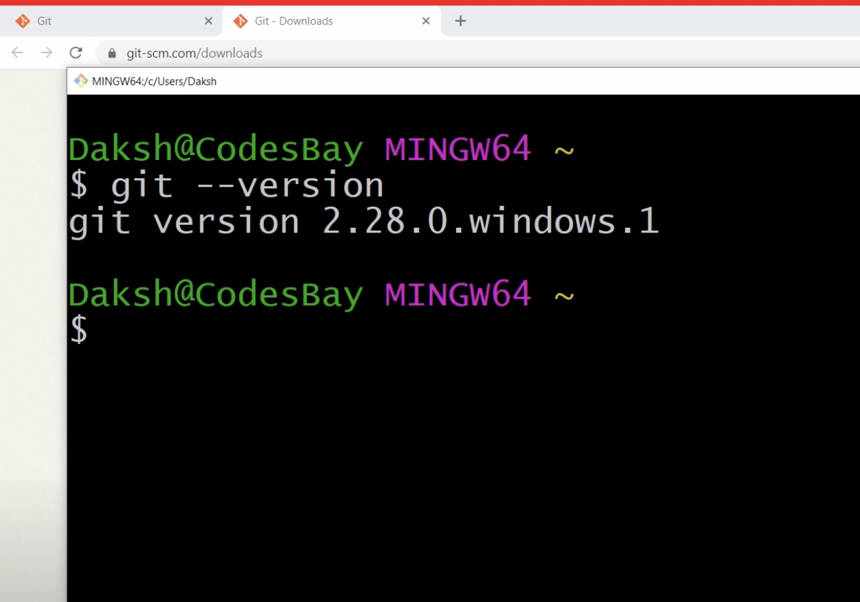

Here's a brief overview of Git's history and installation process, as well as some additional context to your explanation:

**History of Git**

* **Origin**: Git was developed by Linus Torvalds, the creator of Linux, in 2005. The Linux community needed a new version control system after their previous tool, BitKeeper, changed its licensing model, making it no longer freely available to them.
* **Motivation**: The need for a distributed, fast, and efficient version control system that supported non-linear development (branching and merging) drove the creation of Git.
* **Development**: Git was designed to be fast, scalable, and able to handle large projects with efficiency. It quickly became popular beyond the Linux community and is now widely used in software development.
* **Repositories**: Some popular platforms for hosting Git repositories include:
  + **GitHub**: A widely used platform for hosting open-source projects, offering collaboration features and community support.
  + **Bitbucket**: A similar platform by Atlassian, which supports Git and Mercurial repositories and integrates well with other Atlassian tools like Jira.

**Installing Git**

1. **Download Git**:
   * Visit the official Git website at [git-scm.com](https://git-scm.com/).
   * Navigate to the "Downloads" section to select the appropriate version for your operating system (Windows, Linux, or MacOS).
2. **Install Git**:
   * Follow the installation instructions specific to your operating system. The setup process may include configuring basic settings, such as your username and email, which Git uses for commit messages.
3. **Verify Installation**:
   * Open a terminal on Linux or MacOS, or Git Bash/Command Prompt on Windows.
   * Run the command git --version to check the installed version of Git. You should see output like git version 2.28.0 or a similar version number, indicating that Git is installed correctly.

**Getting Started with Git**

Once Git is installed, you can begin using it to manage your projects:

* **Initialize a Repository**: Create a new repository with git init.
* **Clone a Repository**: Copy an existing repository to your local system with git clone <repository-url>.
* **Commit Changes**: Stage your changes with git add, then commit them to the repository with git commit.
* **Push/Pull Changes**: Synchronize your local changes with a remote repository using git push and git pull.

This introduction provides a foundation for understanding what Git is, how it works, and how to set it up on your system. In your next steps, you can explore using Git in real-world scenarios, learning commands and workflows that will enhance your development process.

git clone - Command to clone a git repo from a remote server or github

git status - Command to change the current status of the branch and to know the state of changes i.e. Modified, Staged or Committed State

git log - Command to see the last 'N' git commits on the branch

git remote - Command to set and check the remote server e.g. github

git push - Command to push our changes to a destination which can be a remote server or Github

git commit - Command to commit the changes to the local branch which was cloned using git clone

git add - Command to add the changes from Modified State to the Staged State

git restore - Command to restore the file in original state by discarding all the changes or change the file from staged state to modified state

git branch - The command to create a new branch git checkout - Command to go to a particular branch

git log - Command to see the HEAD status in the git

git remote - Command to set and check the remote server e.g. github

git merge - Command to merge the changes between multiple branches

git commit - Command to commit the changes to the local branch which was cloned using git clone

Create a repository:  
<https://github.com/OmarRafique/LearnGit.git>  
  
**$ git clone** [**https://github.com/OmarRafique/LearnGit.git**](https://github.com/OmarRafique/LearnGit.git)

**$ ls**

**LearnGit/**

**$ cd LearnGit/**

**$ ls -la**

*total 17280*

*drwxr-xr-x 4 omarrafique staff 128 Aug 7 18:00 .*

*drwxr-x---+ 103 omarrafique staff 3296 Aug 7 18:00 ..*

*drwxr-xr-x 12 omarrafique staff 384 Aug 7 18:00 .git*

*-rw-r--r-- 1 omarrafique staff 8845539 Aug 7 18:00 Git.docx*

**$ ls**

*Git.docx*

$ **git status** # tells us the status of the repo. Tells us if some files are in **modified, staged or committed** state and how the repo look like in comparison to the code in the user’s github account 'origin/main'.

*On branch main*

*Your branch is up to date with 'origin/main'.*

*nothing to commit, working tree clean*

$ **git log** # tells us all the commits that are being performed on this repo

*commit d3081fa119fb0437431cd30711babfdd9fccb052 (****HEAD -> main****,* ***origin/main****,* ***origin/HEAD****)*

*Author: Omar Rafique <omarrafiqued@gmail.com>*

*Date: Wed Aug 7 17:59:50 2024 -0400*

*Add files via upload*

**$ git log --patch -1** #More about the above command

commit d3081fa119fb0437431cd30711babfdd9fccb052 (**HEAD -> main**, **origin/main**, **origin/HEAD**)

Author: Omar Rafique <omarrafiqued@gmail.com>

Date: Wed Aug 7 17:59:50 2024 -0400

Add files via upload

**diff --git a/Git.docx b/Git.docx**

**new file mode 100644**

**index 0000000..50b652f**

**$vim Git.docx** #edits the file

$**git status**

This might show a file test.doc and say that the file is in ‘modified’ stage.

To bring the file to the next stage do the following:

$**git add test.doc or $git add .**

Now go ahead and check the git status again:  
**$git status**

This will now show that the file is in the next stage i.e. modified. This will be shown by “**Change to be committed**” statement.

What if we want to undo a change we made.



For example we want to move a file status from **staged** to **modified**:

$ **git restore --staged test.doc**

To get rid of all the changes and go back to the status of the file when the repo was created:  
**$git restore test.doc**

After this git status will show nothing to commit, clean. Also, if we print the test.doc file it will not have any change.

**$cat test.doc** #will have no change

Now let us change the file again:  
 $vim test.doc



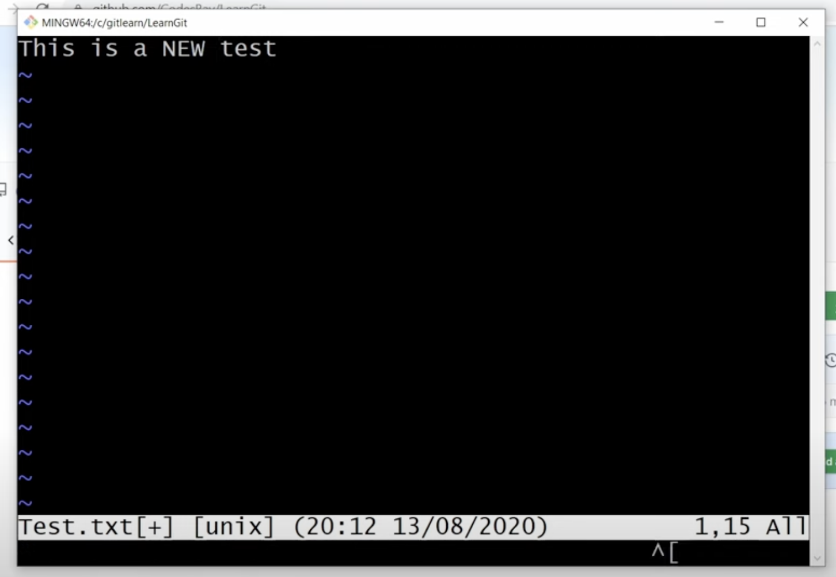

:wq

Now git status will show modifies state:  
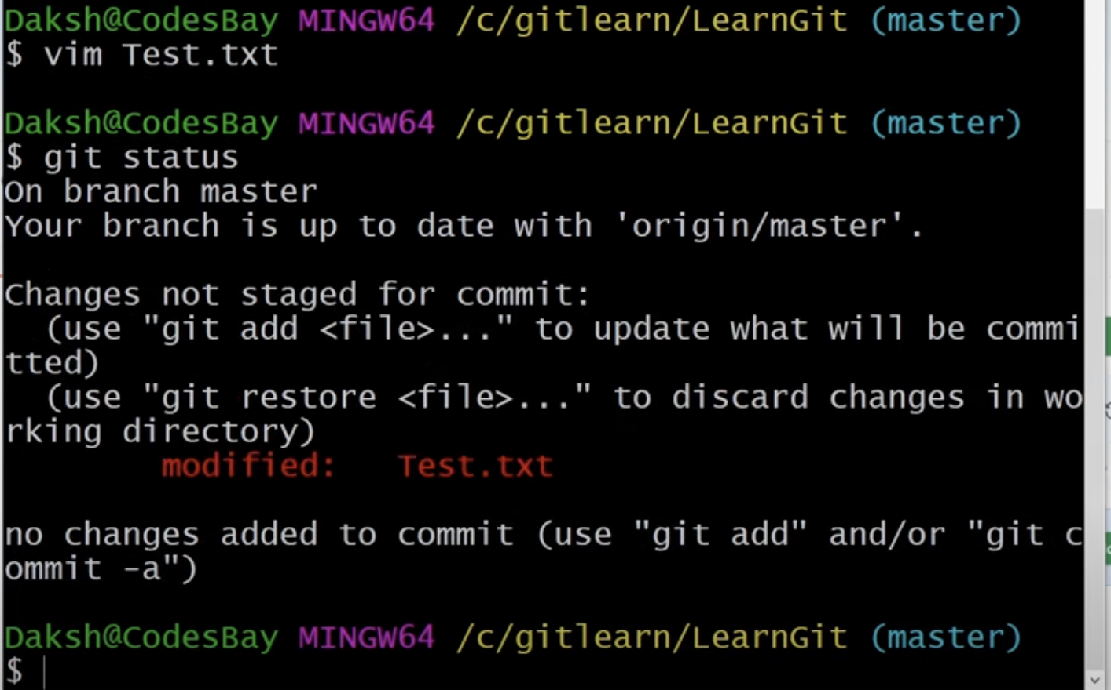

But if we do the following if will go to staged state:  
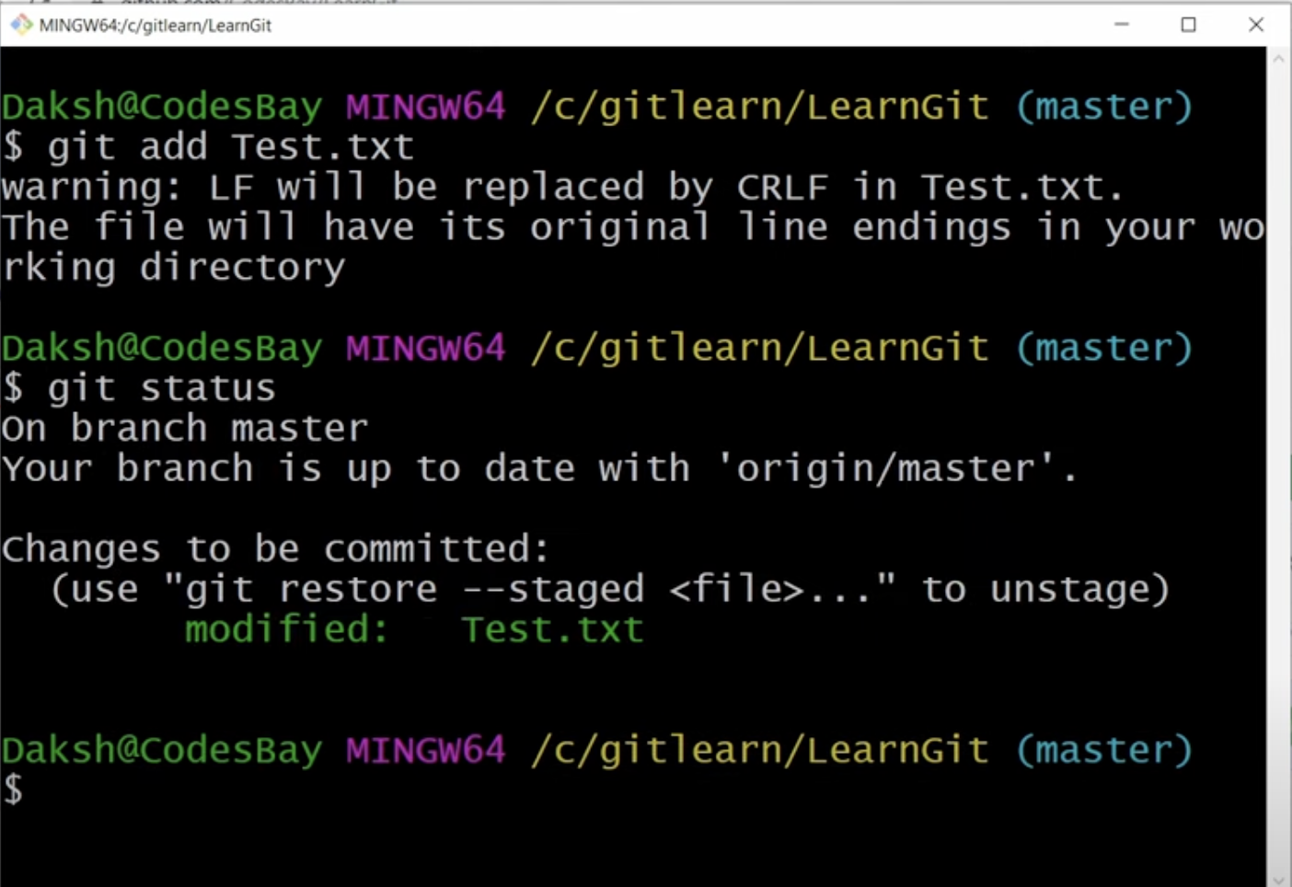

To commit the above we do the following: ( here ‘m’ is for message)  
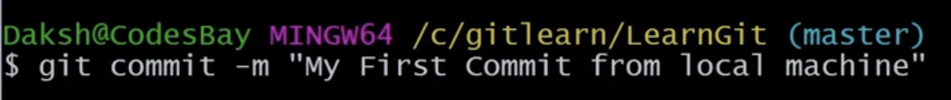

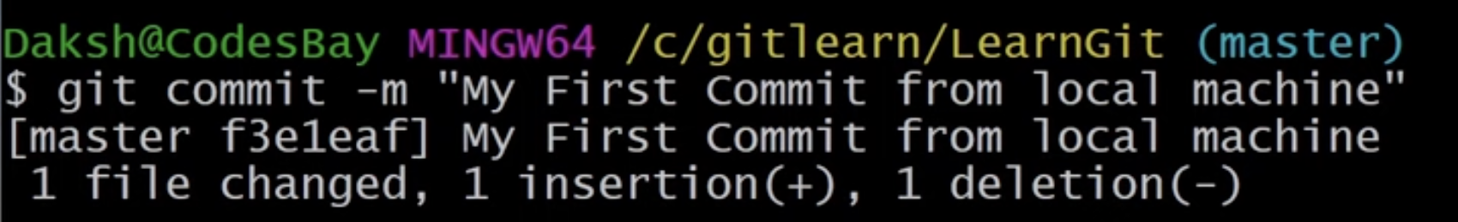

This will commit the file to the local rep0. We have not still uploaded the file to the github page. So if we go to the Github page there will be no new edits there. To understand this, let us go back to git status:  
  
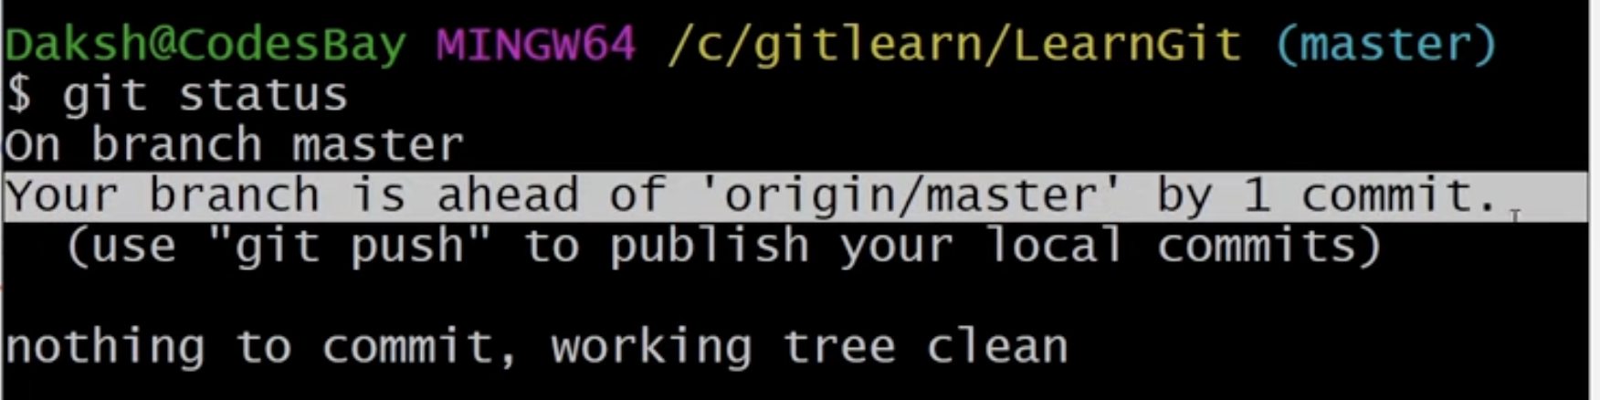

**‘Your branch is ahead of the ‘origin/master’ by 1 commit’** means that from the moment this repo was downloaded or cloned, there is 1 change in it which is not yet reflected in the server. Therefore, to be inline with the server, I need to commit changes back to the github page. How to do that:  
  
There is something called ‘origin/master’. Origin is the remote server and master is the branch. To know the origin, we use git remote -v. It will give a (fetch) and a (push). Fetch is the origin.

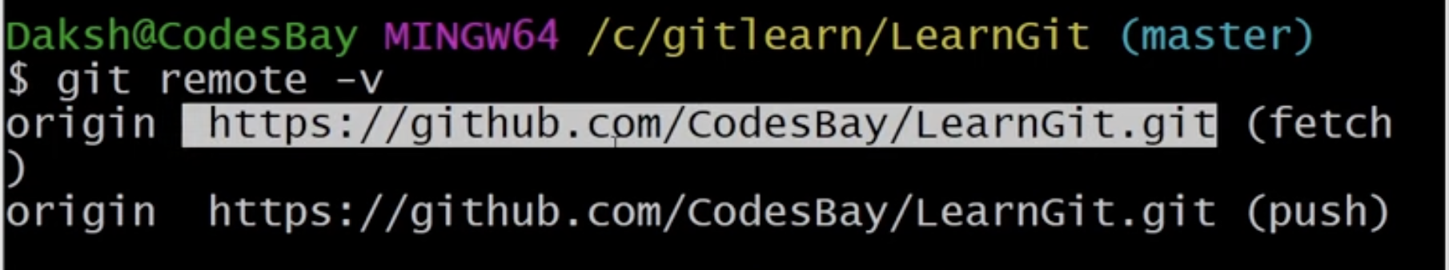

To push the changes to the origin in the master branch we do ‘git push origin master’

as following:  
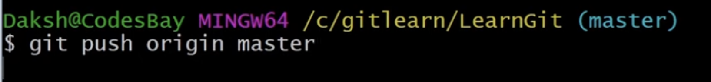

Now, instead of changing an existing file, we want to add a new file:

Let us create a new file

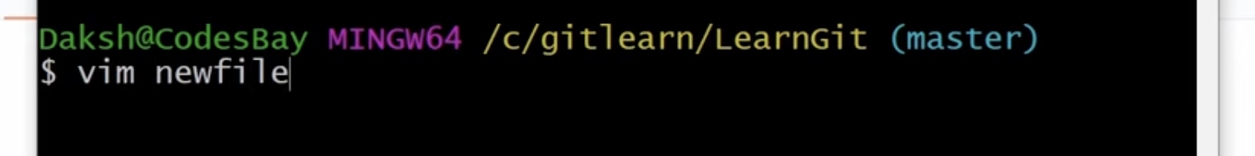

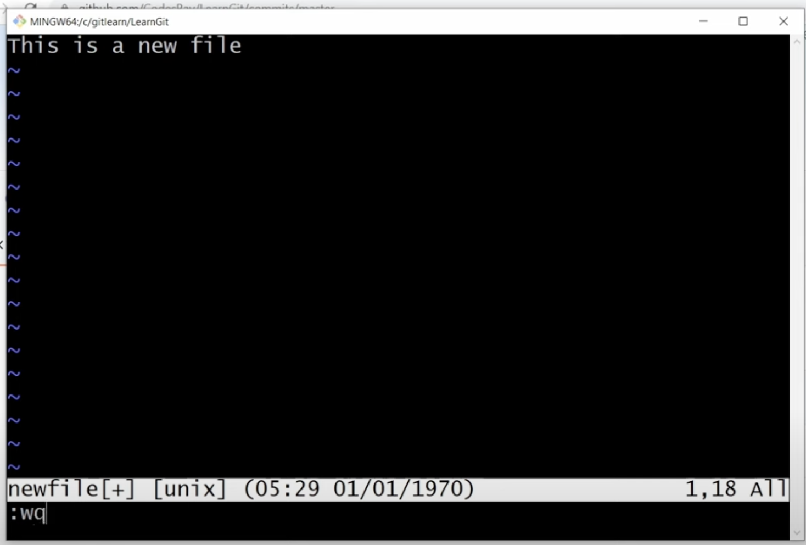

This new file is still in a modified state.

**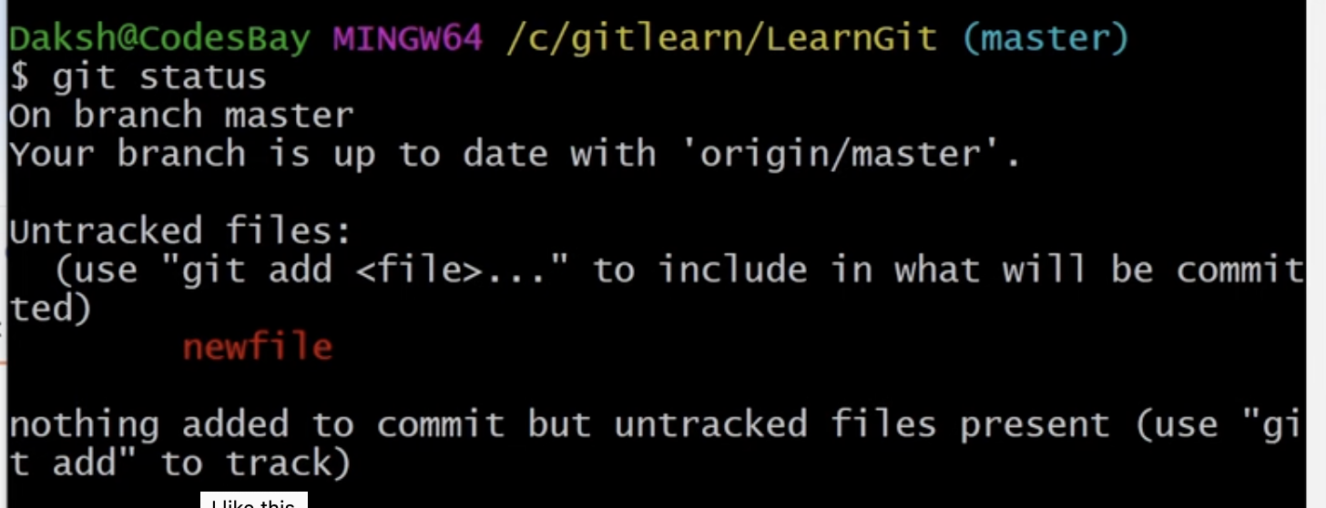  
  
$get add newfile** # get add . will add all the file and we don’t need to add the name of each file individually

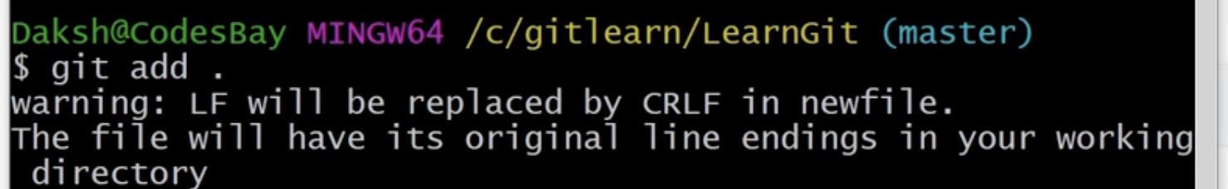

So, it will be in staged state

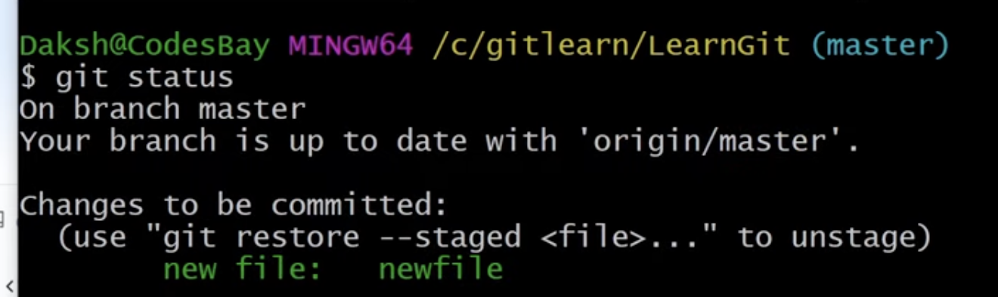

Commit this:  
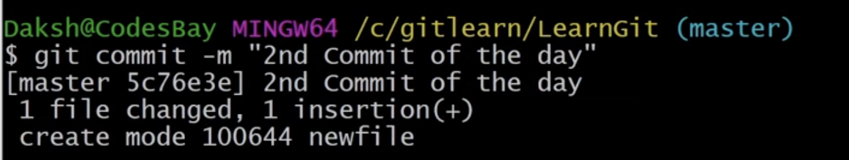

Now do ‘git push origin master’

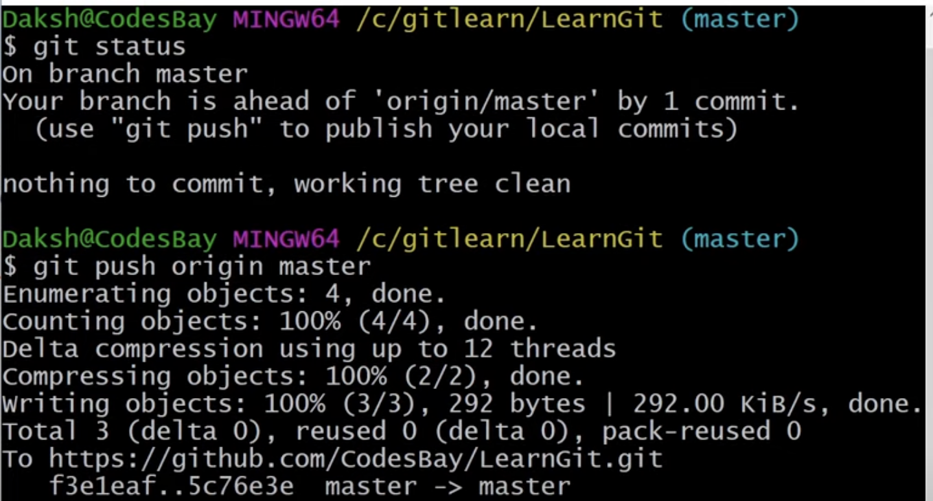

Now refresh your github page and check.

l_EWAS$ git status On branch main Your branch is ahead of 'origin/main' by 8 commits. Is there a way to remove these 8 commits. I dont want then anymore

ChatGPT

If you want to remove the last 8 commits on your local branch main and reset it to the state of origin/main, you can use the git reset command. This will allow you to undo the changes made by these commits on your local branch.

**Option 1: Soft Reset**

A **soft reset** will undo the commits but keep your changes as unstaged modifications in your working directory. This is useful if you want to keep the changes for review or re-commit in a different way:

bash

Copy code

git reset --soft HEAD~8

This command moves the current branch's HEAD back by 8 commits, but it leaves your working directory and the staging area (index) as they were before running the command.

**Option 2: Hard Reset**

A **hard reset** will undo the commits and discard all changes, bringing your working directory back to the last commit that you're resetting to:

bash

Copy code

git reset --hard origin/main

This command resets the current branch's HEAD to the same commit as origin/main and updates both the staging area and the working directory to match. This is a destructive operation and any local changes in the last 8 commits will be lost.

**Important Considerations**

* **Backup:** Before performing a hard reset, it's a good idea to ensure that you have a backup of your work, just in case you want to retrieve something later.
* **Collaborative Work:** If you've already pushed these 8 commits to a shared repository and others might have pulled them, it's generally not recommended to remove these commits using a hard reset unless you are absolutely sure about what you are doing. It can cause confusion and extra work for others to synchronize their work with the rewritten history.

**After Reset**

If your changes were previously pushed to a remote repository and you want to synchronize your branch post-reset:

* **Force Push Caution:** You can use git push --force to update the remote repository with your newly reset local history. This should be done with caution and ideally only after communicating with your team, as it can overwrite history in the remote repository.

Here’s how to force push:

bash

Copy code

git push origin main --force

This command forcefully updates origin/main with the state of your local main branch, which can disrupt other collaborators if not coordinated.

By choosing the appropriate type of reset and carefully managing the impacts, you can effectively remove unwanted commits from your Git history.

4o

reora@ride09:/proj/edith/regeps/regep00/studies/COPDGene/analyses/reora/EWAS_Paper/Longitudinal_EWAS$ git status On branch main Your branch and 'origin/main' have diverged, and have 1 and 6 different commits each, respectively. (use "git pull" to merge the remote branch into yours) nothing to commit, working tree clean

ChatGPT

The message you're seeing indicates that your local branch main and the remote branch origin/main have diverged. This means that there have been commits made to both branches that are not present in the other. Specifically, there is one commit on your local branch that isn't on origin/main, and there are six commits on origin/main that aren't on your local branch.

Here’s how you can address this situation:

**Option 1: Merging the Remote Changes into Your Local Branch**

Since your branches have diverged, you might want to incorporate the remote changes into your local branch by merging:

bash

Copy code

git pull origin main

This command will fetch the changes from origin/main and attempt to merge them into your local main branch. If there are no conflicts, Git will automatically create a merge commit. If there are conflicts, you'll need to resolve them manually before the merge can complete.

**Option 2: Rebase Your Local Changes on Top of the Remote Changes**

If you prefer to maintain a cleaner, linear history, you might consider rebasing your local changes on top of the remote changes:

bash

Copy code

git pull --rebase origin main

Rebasing rewrites your local changes to appear as if they were made on top of the remote changes. This can make your project history easier to understand but can also complicate things if you're not comfortable with Git's more advanced features.

**Option 3: Overwriting Local Changes with Remote**

If you decide that the remote changes are more important and want your local branch to exactly match the remote branch, you can reset your local branch to match origin/main:

bash

Copy code

git reset --hard origin/main

This command will reset your local branch to match the state of origin/main, discarding any local commits that aren't on the remote branch. **Be cautious with this option as it will erase local commits and changes.**

**After Resolving Divergence**

After you've merged or rebased:

* **Verify the merge/rebase:** Check that everything looks correct with git log and by testing your project.
* **Push changes if necessary:** If you've made changes that need to be shared (like a successful merge or rebase that doesn't automatically push), you might need to push your updated local branch back to the remote:

bash

Copy code

git push origin main

This approach ensures that both your local and remote branches are synchronized and up-to-date with each other, reflecting all the changes made on both sides.

**Video 3:**

git branch - The command to create a new branch

git checkout - Command to go to a particular branch

git log - Command to see the HEAD status in the git

git remote - Command to set and check the remote server e.g. github

git merge - Command to merge the changes between multiple branches

git commit - Command to commit the changes to the local branch which was cloned using git clone

**Git Branches - Creating and Managing Branches in git Using Git Branch, Git merge and Git Checkout**

Reminder: git is a distributed version control system i.e. when we clone a repo into a local system, the local system will itself work as a version control system.

